User Service Changes for “Single Acronym” Design

Overview

Current processing
Currently there is exactly one userid for each acronym+exchange combination.

New requirement
In preparation for the RMM project, we need to support multiple logins (“userids”) for a single acronym+exchange. Some user attributes will be associated per userid, while others will be common to all userids for the acronym. Limited userid deletion capabilities will be provided: userid can be deleted if the user has no tradable orders.

Implementation

New Class: UserIdentifierImpl
We will introduce a new class, UserIdentifierImpl, which will encapsulate the userid-specific attributes that have been identified:
- userid
- full name
- active (enabled status)
- preferences (collection)
- userKey (as seen by code external to the UserService implementation)
all other properties (accounts, exchange, etc) will remain associated with the user acronym. Note that the “Preferences” implementation maps to a PREF table that has a user_key column. This column’s values will map to UserIdentifierImpl.getUserKey() rather than UserImpl.getUserKey().

A User is now a composite of a UserIdentifierImpl and a UserImpl. The UserHome will provide instances of a new decorator/aggregator class, UserCompositeImpl, which will contain a reference to a UserIdentifierImpl and a UserImpl. User interface calls will be delegated to these instances,with the exception of the toStruct() methods, which will be migrated from UserImpl to UserCompositeImpl. This will allow the UserHome to behave transparently for all existing methods: query methods will continue to return instances of User for use by the UserService.

Figure 1 - Class Diagram of Modified UserImpl Heirarchy
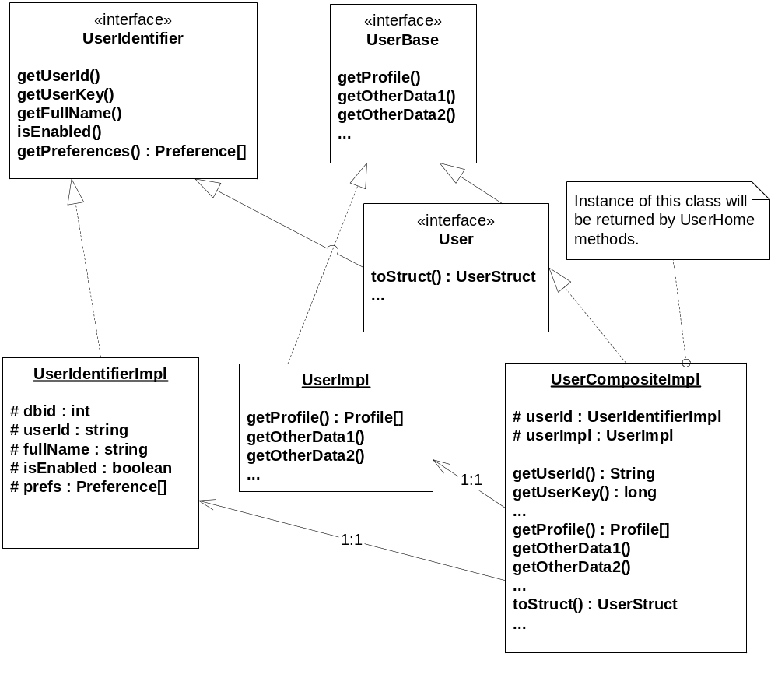

New Database Table
We will introduce a new database table, LOGIN_USERID, to hold the userid-specific data (ie, the table that UserIdentifierImpl will to).
Figure 2 - Relationship to new databaseTables
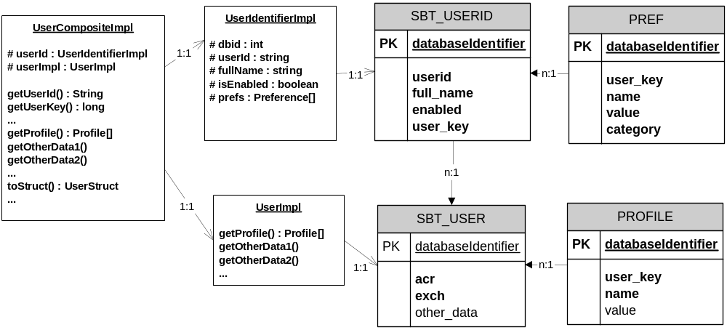

New User Key
Currently, the databaseIdentifier of UserImpl is used as the UUID for a User in the trade server, as well as a “foreign key” for various associated objects within the scope of UserService (UserAccountRelation, Profile, Preference, AssignedClass, etc).

This will change in this project. The UserImpl.databaseIdentifier will continue to be used for foreign key relationships (except for Preference). The UserIdentifierImpl.databaseIdentifier will be used to populate the User.getUserKey() and related IDL struct fields.

For example,
- AssignedClass.getUser() will look for databaseIdentifer in the SBT_USER table.
- UserStructV2.userKey and OrderStruct.userKey will contain the databaseIdentifier from the LOGIN_USERID table.

User Deletion
There is a soft requirement to provide “delete” functionality for users. We will not provide full delete functionality, but a conditional partial delete facility can be implemented. There are two principle problem areas:
- Managing foreign key relations to SBT_USER.
Since this will involve more time and risk than we have budgeted, we will never remove a UserImpl.
- Order management when the owner of the order is deleted.
If an order exists (in almost any state), then there is a significant risk that any order maintenance or order book behavior will fail since the user associated with the order cannot be found. Even cancelled orders pose this risk, as they may be reinstated by a trade bust.

For these reasons, we will provide only limited user deletion:
- Deleting a user will only delete the UserIdentifierImpl and associated Preferences.
This means that the user will effectively be deleted, meaning the user will never be found & returned by the UserHome, but there will be some “junk” database rows left behind.
- A user will not be deleted if the user has any orders in any state on any trade server.
This will be determined by a “lightweight” federated query to all trade servers: A new method “boolean userHasOrders(userId)” will be added to OrderHandlingService, and will be called by the SA before allowing a UserService.delete(userId) to be executed.
- In the morning, in OrderHome.goMaster(), we will double-check that all orders have users. This is a check similar to verifying that orders for expired products are cancelled.

User Summary Struct
A one-dimentional, “light” struct will be defined, based on SAGUI developer specifications, that will be returned by a new query method on UserService.
We may determine that this struct requires supplemental fields that are not otherwise available. If so, then the CacheUpdateConsumer.acceptUserUpdate() method will need to be changed to accept a UserSummaryStruct as a trailing parameter.

User Updates From Membership Download
Any acronym-specific data update will trigger an “update” event for all userid’s of that acronym.

User enabled / disabled
The user “state” provided by the membership download (enabled or disabled) will be applied to all userid’s of the given acronym+exchange. Updates will be published for all userids.

UserId already exists on a “user added” from Membership
The userid requested by the membership adapter may have already been used by an alias; in this case the UserService will select an unused userid by some strategy (ex. suffix an incremental integer until a unique combination is found), and an Alarm will be logged indicating that an alternate userid has been selected. This should be an unusual situation.

User Updates From System Administration
Any update of non-userid-related fields will trigger an “update” event for all userid’s of that acronym.

User enabled / disabled
The SA can enable or disable any user, anytime.

Prevent Modification of User Acronym
We will disallow any changes to user acronym (this is currently permitted by the user service).

Rollout Issues

New Features Disabled During Rollout
Alias creation and user deletion will be prevented during rollout.
This will be managed via an XML flag on UserService. If the rollout flag is enabled, then an user update call from SA will check to see if this update is attempting to change the userid. If so, then a DataValidationException will be thrown, the text of which will explain the situation.

Maintenance of Deprecated SBT_USER Columns
We will continue to update the deprecated SBT_USER columns (full_name, userid, active) on every user update. This is to ensure that if we need to fail back to the old code base, we will “pick up” any updates made to these fields (since the old code is unaware of the new LOGIN_USERID table).

We will enter a DDTS requiring this “dual maintenance” code to be deleted, as well as the deprecated database columns. This can be done at any time after both GC01 hosts have been upgraded.

Initializing the LOGIN_USERID Table
A data conversion script will be run that will create one LOGIN_USERID row for each SBT_USER row. The row values will be copied exactly, including the databaseIdentifier. This will ensure that a “fallback” to old code will preserve user preference settings.

USER_KEY will be same in both tables for new (first) user and acronym.
Dataware house Market Replay uses user_key in order table and SBT_USER and join on userId table. After singleacronym it will will user LOGIN_USERID instead.

After SingleAcronym, when any new acronym is created, one entry will be created in SBT_USER table representing acronym and one entry will be created in LOGIN_USERID table. For rollout purpose, each of these two tables will have same value in databaseidentifier (user_key).
This will take care of failing over to old code for GC. Since user_key is same in both tables, orders, reports created by both old or new code will have same value as user_key.

Scripts(2)
- SQL DDL script for the new table
- SQL Data conversion script for bootstrapping the LOGIN_USERID table.
- SQL Modify script for post-rollout cleanup of deprecated sbt_user columns.

Database(.5)
- New table: LOGIN_USERID
These are the tables which point to SBT_USER.databaseidentifier = user_key or userkey.
After SinglerAcronym, the columns which are in bold will refer to LOGIN_USERID.databaseidentifier and rest will refer to SBT_USER.databaseidentifier.
Current use of userkey and userId

GC tables
AssignedClass.sql - ASGN_CLASS -- USER_KEY

Preference.sql - PREF - USER_KEY

Profile.sql - PROFILE - USER_KEY

UserAccountRelation.sql - USER_ACCOUNT_RELATION - USER_KEY

UserEnablement.sql - SBT_USER_ENABLEMENT - USER_ID , USER_KEY

UserFirmRelation.sql - USER-FIRM-RELATION - USER_KEY

UserSessionAuthorization.sql USER_SESSION_AUTORIZATION - USER_KEY

clearingAcr.sql - clearing_acr - userkey

BC Tables
Quote.sql - SBT_QUOTE - USERID, USERKEY

RFQHistory.sql - RFQ_HISTORY - USERID, USERKEY

SbtQuoteHistory.sql - SBTQuoteHistory - USERID, USERKEY

UserSmartCache.sql - user_smart_cache - USERID, USERKEY
createSbtOrder.sql - SBTOrder - USERID, USERKEY
createSbtOrderHistory.sql - SBTOrderHistory - USERID, USERKEY
tradeReportEntry.sql - sbt_tradereportentry buyerUserKey, sellerUserKey

SetContext(0)
- None

XML/DTD(0)
- None

Homes/Services(15)
- UserHome
- UserPreferenceHome
- UserService

ImplPlan(1)
- GC will be rolled out first and then BC’s
- GCB should also be rolled out before any BC is rolled out to handle GC failover.
- No new functionality (alias creation, user deletion) can not be enabled until BC, FE, and CAS rollout is complete

PerformanceTestingProcedure(1)
- List all scenarios here.

TestingProcedure(2)
Please see SingleAcronym_TestPlan.doc for details.

Update User :

Test1 :
Select any userId which is only one userId for that acronym. Perform regression test for updating a user.

Test2 :
Select any userId which is multiple userIds for that acronym. Perform regression test for updating a userId1 and then userId2.

Special cases:
- Refer following table to find out the properties which are specific to userId and belog to acronym (shared by userId’s). Repeat the test for each property listed.
- Update userId specific property such as user name. Other userId’s name should not be changed.
- Update userId specific property such as user name. Other userId’s name should not be changed.
- Update property which is shared by all userId’s sharing acronyms such as profile. Once any of the property for one userId is changed, it should be reflected for all userIds on all GUIs, including SA_GUI and Trader GUIs.

Unique – By UserId | Shared – By Acronym  Set when Acronym is set. | Notes
UserId |  | No change. Free form text, need to be unique across SBT.
User Name |  | No change. Free form text.
 | Enablements | From server side, currently enablements are associated with userid. It will have to be changed to acronym+exchange.
 | Acronym | When creating a new userId if the acronym+exchange entered does not exist, server will create a new acronym+exchange and it will create a new user.  If acronym+exchange exists, the new user will be created and associated with that acronym and will share the properties with other users.
 | Role | When creating a new user id, as soon as acronym+exchange is selected, role of the acronym+exchange will be assigned. This role will be sent by membership via membershipAdapter. If acronym+exchange does not exist, it will be created and role needs to be specified.
 | User Type | Same as above
 | Firm | Same as above
 | Exchange | Same as above
 | Class Assignments | Same as above
Status / Force Logout |  | No change
On SA_GUI When searching for orders – search by userId |  | The existing “Orders” tab will remain same. Should produce same result as before.
User preferences |  | No change
 | Market Maker Profiles/Account | Same as “role”.
 | QRM Enablements/Disablements  QRM Parameters | Though these are shared, these can be changed for user using sa-gui or by user himself on trader gui. There will be no check if the user who is changing QRM is the one who is quoting for that class.  So U1 can be quoting on IBM and U2 can change QRM on his trader gui without any notification to U1. Also SA-GUI will be able to change QRM
RFP (Request for price) |  | No change. It will remain same as in CAPP project.

OperatorProcedure(0)
- There will be changes to SA-GUI user create and update process which will be listed in SA-GUI operations document. There are no changes to server side operations.

Fallback/Failover
- Pleasee see Rollout Issues section

See section “Rollout Issues” (pg.5) for how this table will migrate.

